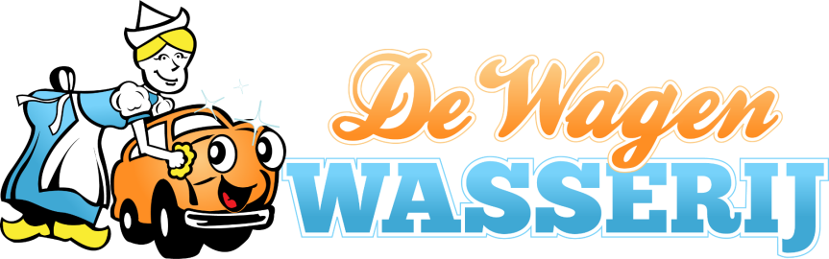

De Wagen Wasserij Fundraising Car Wash Program Terms and Conditions

Ticket Sale Information:
- Certificates are good for one tunnel wash.
- Organizations can buy certificates in any quantity.
- Cost of the certificates to the organization are $5.00 each.
- Certificates can be sold for any amount the organization would like
- Certificates can be picked up at our site at 119 Grover St. Lynden, WA 98264.
Payment:
- Certificates must be purchased at least three weeks prior to the fund raising event.
- Certificates can be purchased with Credit Card or Check from Organization.
Proceeds:
- The Organization is responsible for collecting all proceeds from the resale of the certificates for the fundraising event.
Unsold Certificates:
- Unsold certificates must be returned within 45 days of being picked up for a full refund.
- No refund will be given for lost, stolen, or damaged certificates.
Restrictions:
- Certificates cannot be sold within 1000 feet of De Wagen Wasserij's car wash location.
- Certificates cannot be used for personal use, donated, or given away. (Unless pre approved)
- Certificates are not valid for large commercial or oversized vehicles, as they will not fit into the tunnel wash.
Form must be signed prior to participating in program. Date: ____________
Date certificates were picked up. Date:____________
Name of Organization: Name of Representative:
_______________________ (Print) _______________________________
Organization Tax ID # (Sign) _______________________________
_______________________
# of certificates purchased: # of certificates returned:
_______________________ _______________________

